(Sprint 2 Plan) Island Reservation

**Goal**: The goals of this sprint are to design more pages for the website and connect the frontend to the backend through multiple endpoints.

**Task listings:**

Note : User Stories carried over from Sprint 1 include Story 1-2

**User Story 1: As a customer of a booking service, I want a way to be able to make an account so I can save all of my bookings. (21 story points)**

Task 1: Design a sign up page. (4)

Task 2: Design a login page. (4)

Task 3: Create a collection in the database to hold user information. (0.5)

Task 4: Create a sign up endpoint that can send new user information to the database and a sign up schema. (4)

Task 5: Sign up new users using the sign up endpoint. (3)

Task 6: Create a login endpoint that checks if the user’s information matches the information in the database and a login schema. (4)

Task 7: Log a person into their account using the login endpoint. (3)

**User Story 2: As a person who wants to reserve an island, I want a way to be able to see a list of available islands so I can reserve them. (13 story points)**

Task 1: Design a template page where all of the islands will be displayed. (5)

Task 2: Create a collection in the database to hold all of the island information. (0.5)

Task 3: Search up island information online and put it into the database. (3)

Task 4: Write a get endpoint that returns all of the island information. (4)

Task 5: Display the information from the database on the website. (1)

**User Story 3: As a person who wants to reserve an island, I want to be able to sort the list of available islands by different criteria (like price, land size, or rating) so I can easily find the island that is best for me. (21 story points)**

Task 1: Figure out what the (3) best sorting criteria would be (0.5)

Task 2: Write a get endpoint that can fetch all of the island information that satisfies the 1st criteria and be able to call it on the frontend. (4)

Task 3: Write a get endpoint that can fetch all of the island information that satisfies the 2nd criteria and be able to call it on the frontend. (4)

Task 4: Write a get endpoint that can fetch all of the island information that satisfies the 3rd criteria and be able to call it on the frontend. (4)

Task 5: Display the information from the various endpoints on the website (1)

**User Story 4: As a user of an island reservation service, I want a homepage to be able to see all of my account information including the bookings that I’ve made. (13 story points)**

Task 1: Design a basic home page that has areas for the user’s account information and their bookings. (4)

Task 2: Write a get endpoint that can fetch the user’s account information and be able to call it on the frontend. (3)

Task 3: Write a get endpoint that can fetch the user’s bookings and be able to call it on the frontend. (3)

Task 4: Display all of the information in the appropriate areas on the website’s home page (1)

**User Story 5: As a user, I want my account login information to be secure so my account doesn’t get hacked. (8 story points)**

Task 1: Look into a way to hash the password when the user is signing up/logging in. (5)

Task 2: Implement the password hashing technique, take in the user’s password, and hash it on the frontend (2)

Task 3: Store the hashed password in the database (0.5)

**Team roles:**

Abdel Rahman Alnajjar : Frontend Developer

Suneet Bhandari : Frontend Developer

Minghui Wen : Frontend Developer

Maiah Pardo: Frontend Developer

Jonathan Ly : Backend Developer

Wilson Chen : Backend Developer

Jose Jimenez : Backend Developer

**Initial Task Assignment:**

Minghui Wen: User Story 2, Task 1 create a gallery page that displays information about islands.

Abdel Rahman Alnajjar: User Story 1, Task 1 create login page that takes user information.

Wilson Chen: User Story 1, Task 4 connect signup page to database.

Suneet Bhandari: User Story 2, Task 1 Create a Front page for the website.

Jonathan Ly: User Story 2, Task 2 Set up a collection to hold island info.

Jose Jimenez: User Story 3, Task 1 Figure out what criteria to sort by.

Maiah Pardo: User Story 4, Task 1 Design a basic logged-in homepage.

**Burnup Chart:**

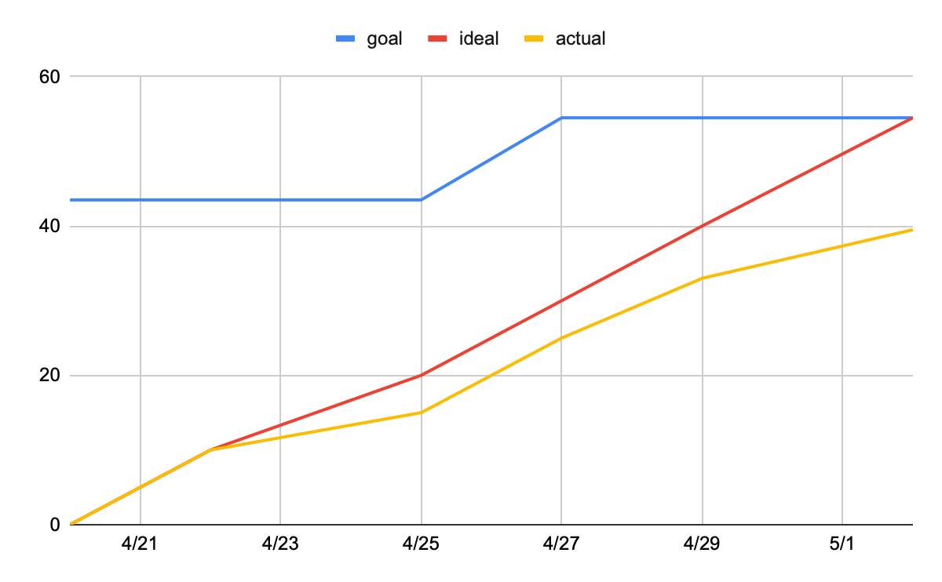

**Scrum Board:**

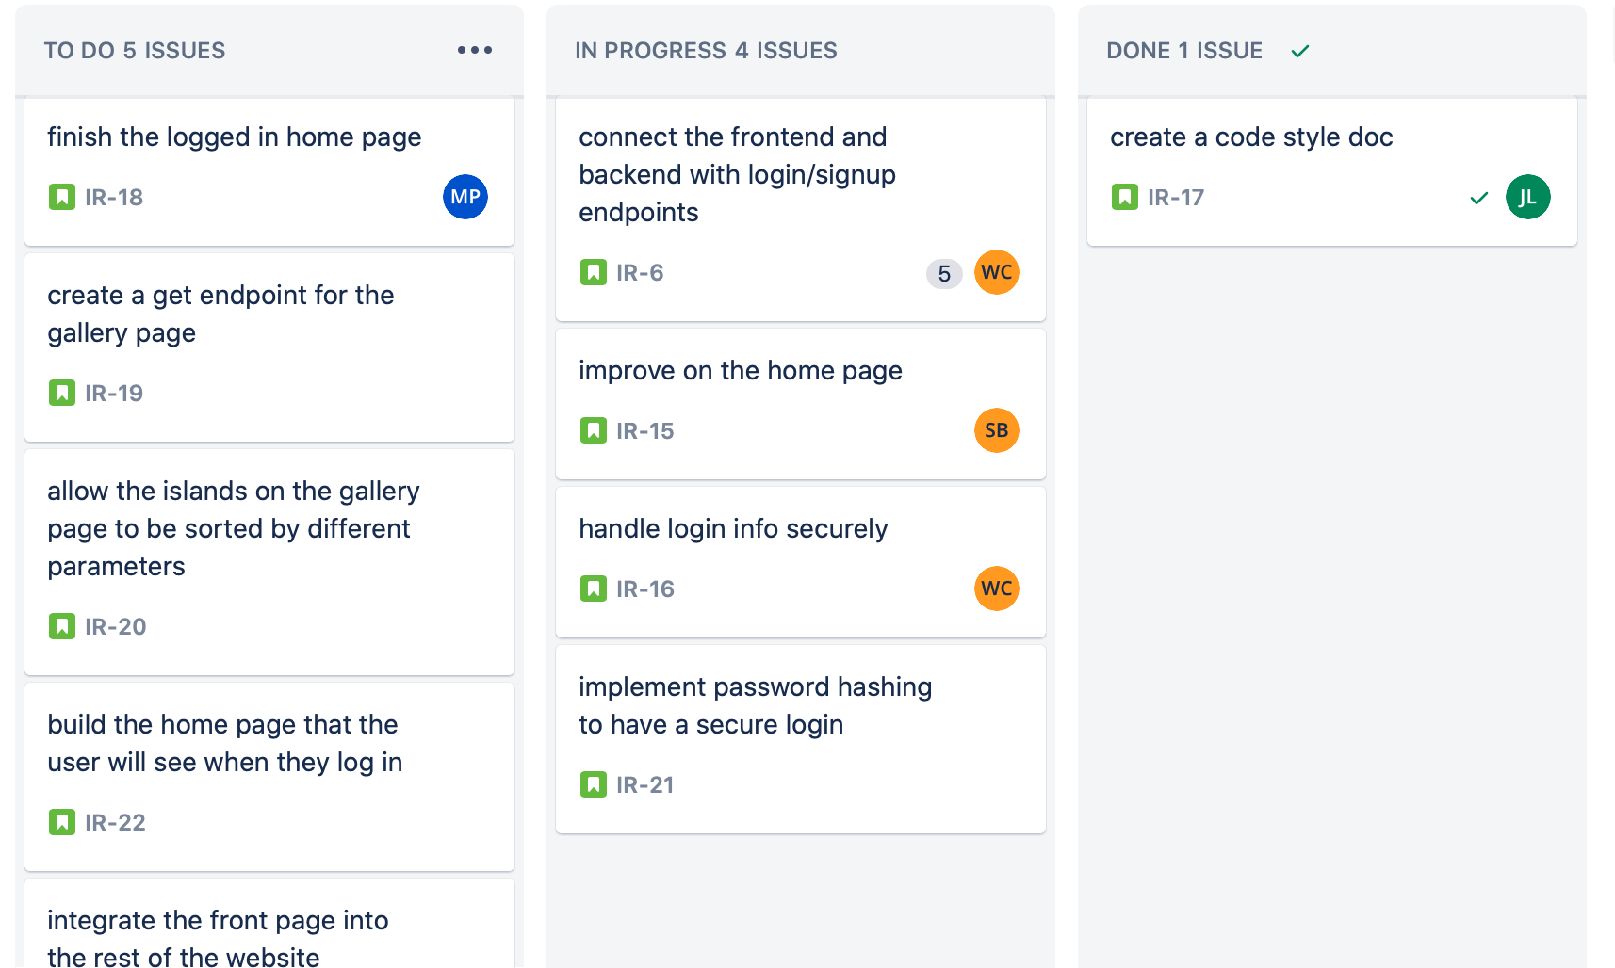

<https://islandreservation.atlassian.net/jira/software/projects/IR/boards/1>

**Scrum Times:**

Mon/Wed/Fri : 9:05am - 9:30am

TA meeting: Monday Trevor 1:30pm - 2:15pm